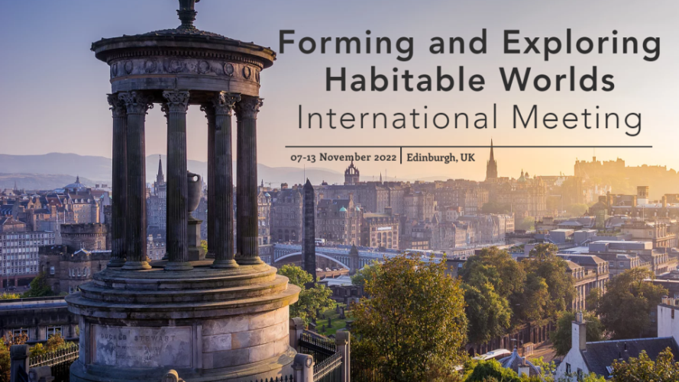

Bursary Application Form
Bursary support is awarded on the basis of need. Potential delegates are, in the first instance, encouraged to access meeting attendance monies where available to them on active grants, funded studentships, or other sources accessible to them. Meeting access and caring support bursary applications for presenting delegates of the inaugural Forming and Exploring Habitable Worlds meeting taking place in Edinburgh, November 2022, will be reviewed by this event’s scientific committee. Successful applicants will be informed of the value of their award and the awarding body(ies) specific to their grant shortly after the close of abstract submission on April 22nd 2022.
Bursary support will be paid to successful applicants on a reimbursement basis. This means that transactions will be completed during or shortly after the meeting itself and proof of expenses directly incurred (in the form of payment receipts) will be required at that time. We appreciate that there may be just one or two special cases, if highlighted and justified in the application form, exceptional cases of financial hardship where reimbursement may not be practical may be carefully considered and discussed. Bursaries funds will contribute to a reasonable portion of meeting access costs and / or required caring expenses, and other support and / or matched funding should be declared.
To be considered for bursary funding, please complete this form and return a scan or electronic copy to habworldbursaries@gmail.com by midnight UK-time Tuesday May 3rd 2022.
All applications must be accompanied by a signed letter on headed paper, or verifiable email, from the relevant supervisor / line manager / Head of Dept. or School confirming your affiliation, disability or caring needs (if known to them) and granting written approval to participate in this meeting. If an applicant presenting work has recently concluded employ / a qualification and faces financial barriers to participation this should be stated in the document provided by a recent employer / supervisor / manager or trusted community member.
Who is eligible to apply?
Meeting access bursaries are available on a competitive basis to those presenting their work in-person or remotely either as solo / dual presenter talks, a poster, or as a panel member for planned question-led / discursive exchange.
Eligible applicants are those presenting their research at the meeting and those given priority for bursary support include:
- research students without access to alternative funds,
- people resident in low or lower-middle income countries (refer here),
- postdoctoral researchers who do not hold personal fellowships,
- refugee or displaced scientists with no other source of meeting funds,
- those who can demonstrate financial hardship during 2022 and at the time of the meeting,
- those proven to be on different forms of insecure contracts and without alternative funds,
- and others facing verifiable financial barriers to participation, either in-person or virtually.
What costs can funding be sought for?
Bursaries can provide to eligible applicants a reasonable percentage of the total costs for:
- registration,
- ± travel expenses,
- ± accommodation fees,
- ± carers fees / special provisions for disability or significant illness.
It should be demonstrated that costs are directly incurred by the applicant to enable participation in the Forming and Exploring Habitable Worlds meeting. Applications from both in-person and remote-access (percentage support of registration ± eligible caring costs) participants will be considered.
Wherever travel costs are involved the applicant should strive to use the most economical option available to them. Low carbon travel choices will be viewed favourably wherever possible and carbon-offsetting is encouraged in all cases.
We hope to be positioned to assist applicants in need of help with reasonable caring costs. This category refers to those that can only participate in the meeting if financial barriers are addressed by relieving the proven costs of child care needs, disability care / severe ill health support, and/or substitution of a paid carer for elder or other care where the applicant is usually the care giver. Requests of this type should be justified for the assessors via the second text box of this form.
For all requests, team members involved in the handling and assessment of bursary applications work with a confidentiality agreement in place. They may follow-up to ask you for additional information to ensure that your application is eligible and appropriate for the remit of the funds.
If possible for you, inclusion of a statement verifying your caring situation, disability or ill health status should be included in the signed and dated letter of support on headed paper from the applicant’s supervisor / line manager / Head of School or Department. We appreciate that in some cases the disability, ill health, or caring circumstances of an applicant may not be well known, or could be a matter of discretion, not possible to include in the letter referred to. Where relevant, please be prepared for further questions regarding your disability, health condition, impairment, and/or caring commitments but be assured that we seek to ensure time involved is reasonable and any information you share will stay confidential.
Please also note that eligible costs for carer personnel concern hired staff to fulfil caring needs due to the commitments of the applicant to and during the meeting.
Are there bursaries dedicated to the retreat to Gartmore House?
With regard to the optional retreat to Gartmore House, those qualifying as priorities for partial support of in-person attendance of the retreat must present work at the main event and:
- be in training as research students,
- hold an insecure / contract position,
- be from low or lower-middle income countries,
- face added financial and other challenges due to verifiable disability or specialist health needs,
- and / or be without alternative funds.
As places for the retreat are limited to around 30, PhD-students and/or individuals who request and qualify for support for this aspect of the event will be given priority to attend at Gartmore House.

Unless stated otherwise, all sections of this form are mandatory for applicants to complete.

Applicant name: _________________________________________________________________

Employer of Institutional affiliation:__________________________________________________

Country in which you are based:____________________________________________________

Position (tick one):
- Masters student
- PhD student
- Postdoc without a personal Fellowship on fixed-term contract employ
- Other worker with fixed-term contract employment.
- Other role
Job title or brief description of circumstances :______________________________________

Name of Supervisor, Head of Dept./ School, or Line Manager: ___________________________

Support requested to assist with (tick all that apply):
- Remote-access registration costs for the main event
- In-person registration costs for the main event
- Travel costs to Edinburgh
- Accommodation fees in Edinburgh
- Caring costs
- Costs for attendance of the event’s retreat to Gartmore House

Abstract title: __________________________________________________________________

Please summarise your study and/or employment history (around half a page in total. Should you have one, include a link to your personal professional website. Adjust text box if required):
Insert text
Reasons for your need for support to enable meeting participation (adjust text box if needed).
This justification should be roughly half a page or less, and must give clear reasons why financial support is not available to you from other sources at this time. Especially if, for example, if you are receiving a research council studentship award or are part of a research team with active grants.
Those requesting support for carers costs, or provisions associated with disability needs, to enable their participation should briefly outline these matters here.
Insert text
Statement of all costs (in £) showing other support and how the bursary will be used, with stated values ± appended proof of expenses to be incurred (enlarge text box if required).
Clearly list the breakdown of expenses for which you are applying for a reasonable level of support. Include here costs incurred for caring expenses / provisions to support needs of a disability.
Where relevant, state if intending to attend the retreat to Gartmore House as well as the main part of the event in Edinburgh.
Please indicate the sum of monies you request through the bursary scheme and indicate the likely sources of other funds or matched awards.
Subject to the nature of the request submitted by the applicant, awards to individuals by the meeting’s team will range from a contribution toward remote-access registration to a likely maximum of a few hundred pounds to alleviate the burden of other eligible expenses (+ possible further caring costs if possible). The response text for this section should total around half a page.
Insert text

Section for any additional text (optional).

Declaration
I hereby declare that I have read and will adhere to the ethos of this meeting, all relevant codes of conduct of meeting sponsors, and that the content of this application is complete, accurate, and true.

Sign: ______________________________________

Date (day / month / year): _____________________

Checklist
- Ensure that you have completed all sections of this form and that the declaration is signed and dated.
- Please append a copy of your submitted abstract.
- Check that you have appended any supporting evidence that you may wish to include.
- Please append or ensure the submission (before April 25th 2022) of the required verifiable email or signed letter on headed paper from the relevant supervisor, line manager, or Head of Department / School.

Prior to submission to habworldbursaries@gmail.com, please ensure completeness and that all required supporting materials are appended to this document. Should you have any questions relating to your bursary application, please send an email to the above gmail account.
Any in-person participants requiring travel visas for which letters proving participation in the event are required should contact the Chair as soon as possible.
All applicants will be notified of the result of their requests a few weeks after April 25th 2022. At that time any added details related to the remit and administration of their award will be communicated.
After the meeting takes place in November 2022, those successful in their requests will be asked to provide a report on one page of A4 summarising how the event was experienced by them and how the award helped enable the dissemination of their research, general networking, professional development and/or career prospects. Text ± images can be used. It may prove possible to publish these short reports as part of the blog or other forum of a learned society, under which circumstance authors will be contacted to request permission to do so.

